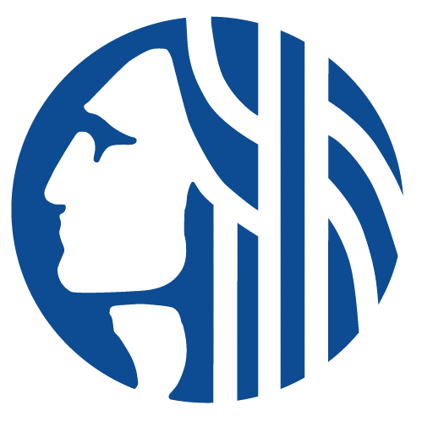

CENTRAL WATERFRONT OVERSIGHT COMMITTEE
November 10th, 2022
Seattle Aquarium/Webex (Hybrid meeting)
4:00-5:00pm
Webex Meeting Link

Agenda
- Welcome
- Park Rules and Public Safety
- Work Plan for the new year
- CWOC reappointments
- Annual review of Friends/SPR reports
- Park Inspections

